One-Verse Evangelism
Many times we feel that to be effective in evangelism we have to create complex illustrations and memorize a seminary-worthy number of verses. But the gospel is most powerful when shared with love, clarity, and (sometimes most importantly) simplicity.
One-Verse Evangelism® is a simple, interactive way to share Christ’s love conversationally and visually. It is based on asking questions and sharing truth simply. It’s easy to learn because it uses just one verse. One-Verse Evangelism can be shared in just 10 or 15 minutes, but can have impact for a lifetime.
Here’s a brief look at how it works. Let’s say God is leading you to share the gospel with your neighbor, Jeff. Write out Romans 6:23 on a piece of paper or a napkin: “For the wages of sin is death, but the gift of God is eternal life in Christ Jesus our Lord” (NIV). All you need is contained in this single passage. Ask Jeff if he would like to see a simple diagram based on this verse that will explain God’s relationship with mankind (us).

Wages

Circle the word “wages” and ask, “How would you feel if your boss refused to pay you the wages that were due to you?” The answer, of course, is that he would want justice—in this case, the wages he had worked for. Deep down, we all know that it is only right that we get what we deserve. Similarly, we earn “wages” from God for how we have lived our lives.

Sin
Draw a circle around “sin,” asking your neighbor Jeff what he thinks when he hears this word. You might explain that sin is more an attitude than an action. It can be either actively fighting God or as simple as excluding Him from our lives. You can ask, “Has God ever seemed far away?” If he says “Yes,” you can explain that that’s one of the things sin does—it makes God seem far away. Now draw two opposing cliffs with a gap in between.

Death
Circle this word and ask what thoughts come to mind. Explain that death in the Bible always means some kind of separation—in its most basic sense, separation from life. Because God is the author of life, a spiritual death simply means separation from Him.

BUT
While circling this word, mention that it is important because it means that a sharp contrast in ideas is coming. What we have just looked at is the bad news; what comes next is the good news.

Gift
Draw a circle around this word. Ask, “If wages are what a person earns, then what is a gift?” Remind Jeff that though every gift is free for the person receiving it, someone still has to purchase it.

of God
Circle this and explain that the gift you are talking about is free. It is from God Himself. It’s so special that no one else can give it. Ask, “How do you feel when someone gives you a special gift?”

Eternal Life
Circle these two words next, and then ask, “How would you define these words?” Contrast one side of the cliff, death, with the other side, eternal life. Ask, “What is the opposite of separation from God?”

Christ Jesus
Write these words so they create a bridge between the two cliffs. Help your friend to consider that just as every gift has a unique giver, only Jesus Christ can give the gift of eternal life.

Trust
Write this word over the bridge you just drew. Explain that a true friend is a friend you can trust, and tell Jeff that Jesus is offering to be a true friend to him. All Jeff has to do is admit that he is responsible for his sin—either of fighting against God or excluding Him from his life. Trusting Jesus means believing that He has power to forgive us for rejecting God and that He will wash us clean from all that we have done wrong in life. At this point, you can ask him if he wants to start a relationship with God that will last forever. If he says “Yes,” invite him to pray a short prayer in his own words, asking Jesus to forgive him and make him new.
Close by reminding him that this simple illustration shows what God is like: Someone who really cares about people—especially him. Invite him to read all about it in the Bible–the Gospel of John is a great place to start.

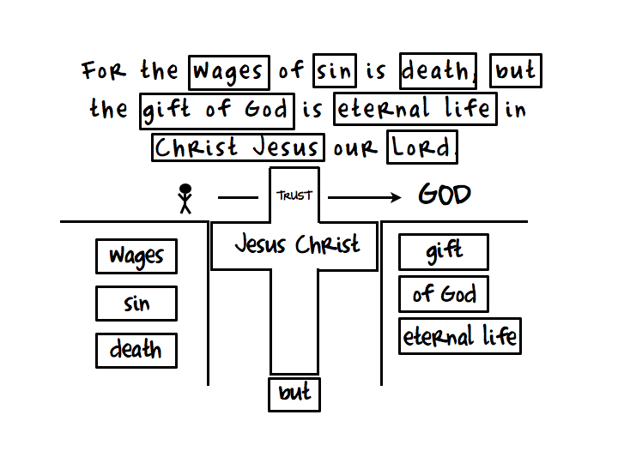
Note: all text taken directly from the The Navigators website. This document created simply for convenience in printing.
https://www.navigators.org/resource/one-verse-evangelism-share-christs-love-conversationally-visually/

